|  |  |  |  |  |  |  |  |  |  |  |  |  |  |  |  |  |  |  |  |
| --- | --- | --- | --- | --- | --- | --- | --- | --- | --- | --- | --- | --- | --- | --- | --- | --- | --- | --- | --- |
| **INTERSTATE CONTAINER CORPORATION** | | | ***Date:* 03/09/2017** | ***Spec #:*** | | | | | | | | | | ***Design #:*** | | **161023-01** |  |  |  |
|  |  |
| ***Customer:* DeMet's Candy** |  |  |  |  |  |  |  |  |  |  |  |  |  |  |  |  |  |  |  |
|  |  |  |  |  |  |  |  |  |  |  |  |  |  | ***Cut*** | **218 in.** | |  |  |
|  |  |  |  |  |  |  |  |  |  |  |  |  |  |  |  |
| ***Description:* SHIPPER - 032 - 24ct Bag [Lefthand 1/8"gap]** | | |  |  |  |  |  |  |  |  |  |  |  |  |  |  |
|  |  |  |  |  |  |  |  |  |  |  |  | ***Crease*** | **163 in.** | |  |  |
|  |  |  |  |  |  |  |  |  |  |  |  |  |  |
| ***Style:* RSC** | ***Revision Info:* [0] 03/09/2017:[Lefthand 1/8"gap]** | | |  |  |  |  |  |  |  |  |  |  |  |  |  |
|  |  |  |  |  |  |  |  |  |  |  |  |  |  |  |  |
|  |  |  |  |  |  |  |  |  |  |  |  |  |  |  |  |
| ***I.D. :* 18+1/4 x 9+1/2 x 13** | ***Blank size:*** | **22+13/16 x 57+1/2** |  |  |  |  |  |  |  |  |  |  |  |  |  |  |  |  |  |
|  |  |  |  |  |  |  |  |  |  |  |  |  |  |  |  |  |
| ***Board:* 44 C K** | ***Combination:*** | **42-36M-42** | ***Designer:* Alan Groff** |  |  |  |  |  |  |  |  |  |  |  |  |  |  |  |  |
|  |  |  |  |  |  |  |  |  |  |  |  |  |  |  |  |

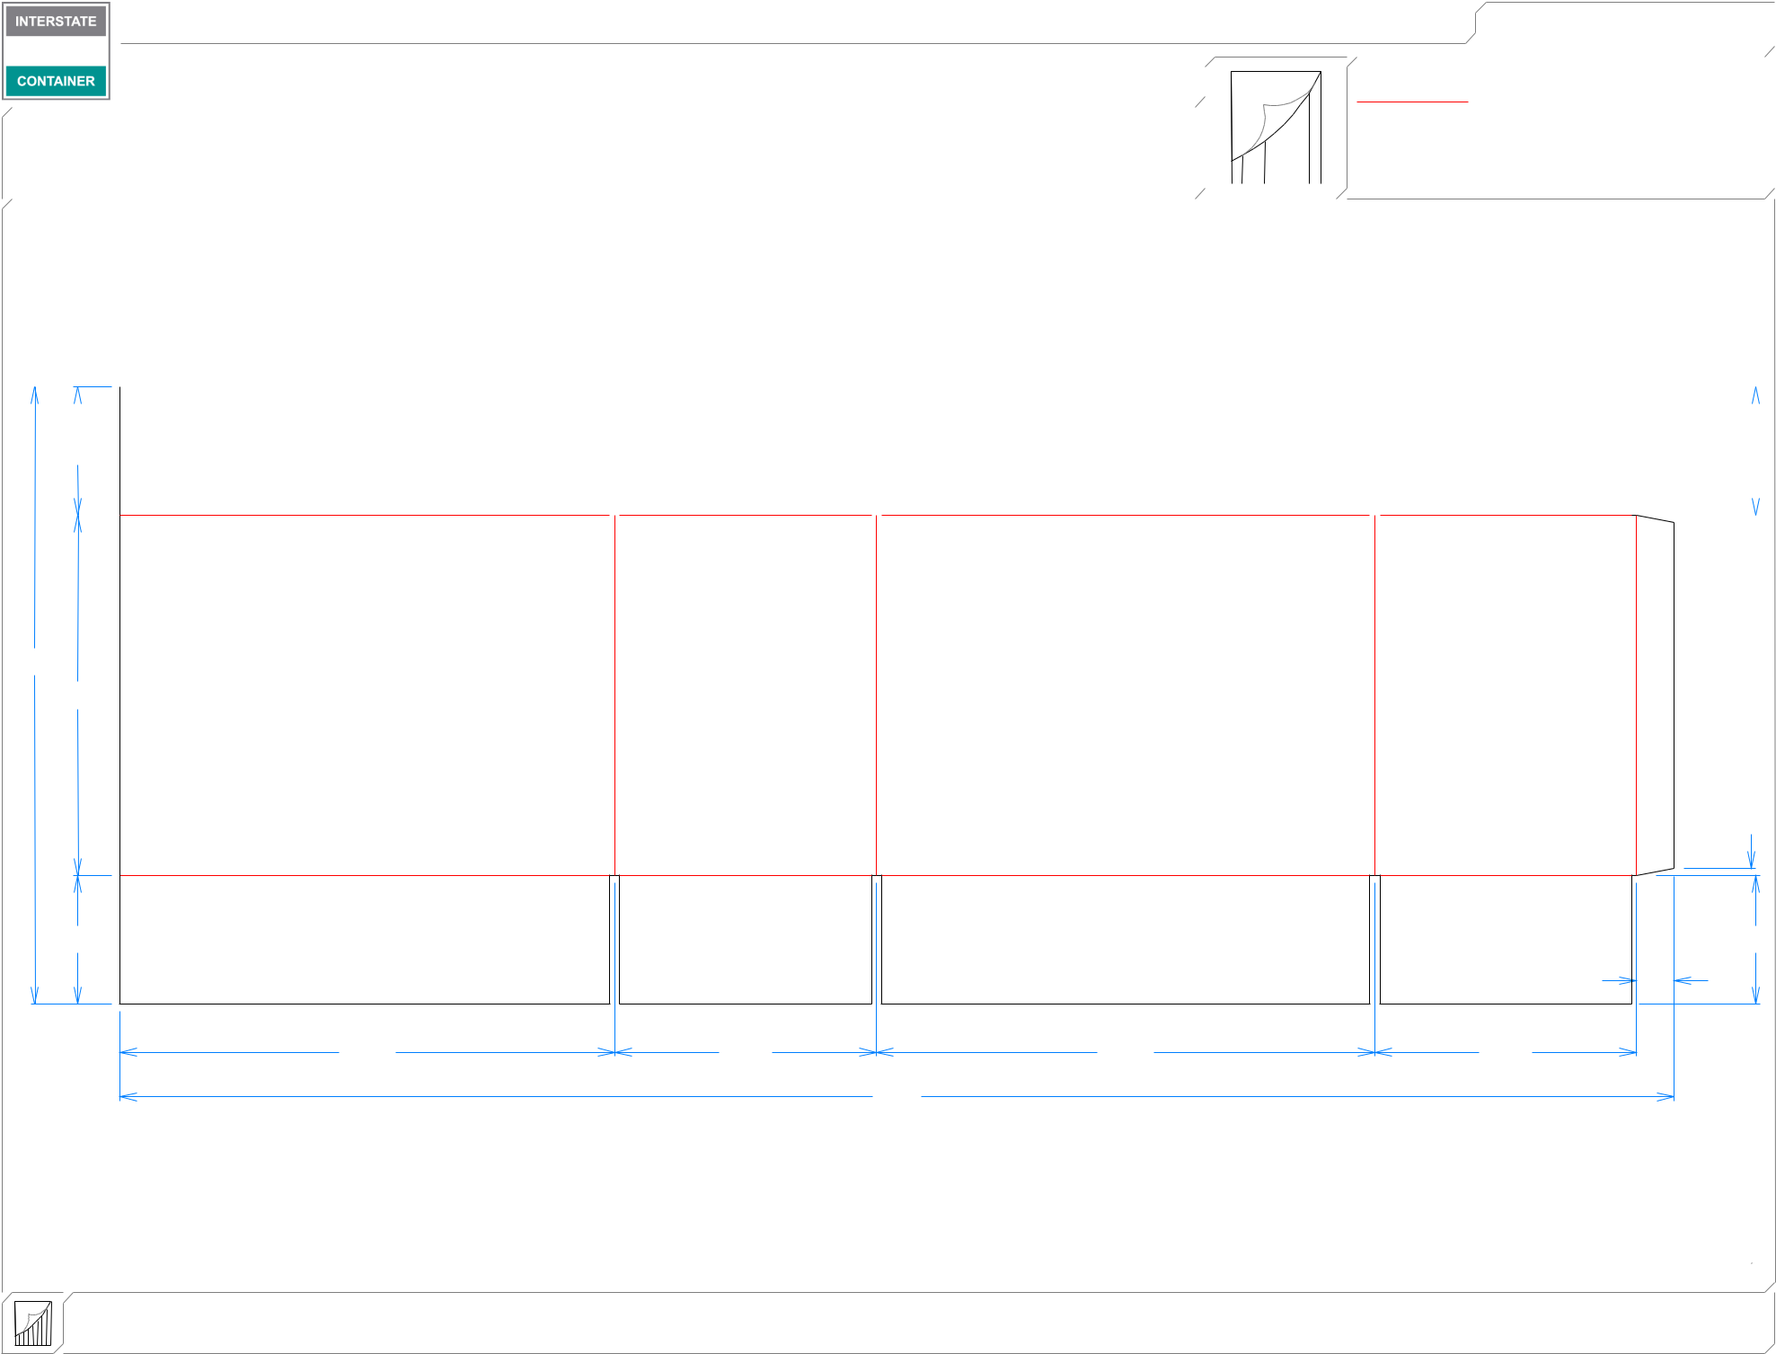

|  |  |  |  |  |  |  |  |  |  |  |  |  |  |  |  |
| --- | --- | --- | --- | --- | --- | --- | --- | --- | --- | --- | --- | --- | --- | --- | --- |
|  |  |  |  |  |  |  |  |  |  |  |  |  |  |  |  |
| 43*/*4 | | |  |  |  |  |  |  |  |  | 43*/*4 | | | | |
|  |  |  |  |  |  |  |  |  |  |  |  |  |  |  |  |

2213*/*16

135*/*16

|  |  |  |  |
| --- | --- | --- | --- |
|  |  |  | 1*/*4 |
| 43*/*4 |  |  | 43*/*4 |
|  |  |  | 13*/*8 |
| 185*/*16 | 911*/*16 | 187*/*16 | 911*/*16 |
|  |  | 571*/*2 |  |

|  |  |  |  |  |
| --- | --- | --- | --- | --- |
| **inside view** | ***notes:* x6 large bags of Flipz laying down** | |  |  |
| **Vertical Corrugation** | ***Qty/unit:*** | ***Area - waste:* 8.93 sq. ft** | ***Waste on blank:* 2.0%** | ***Piece weight - waste:* 1.23 lbs./556.19 g** |